

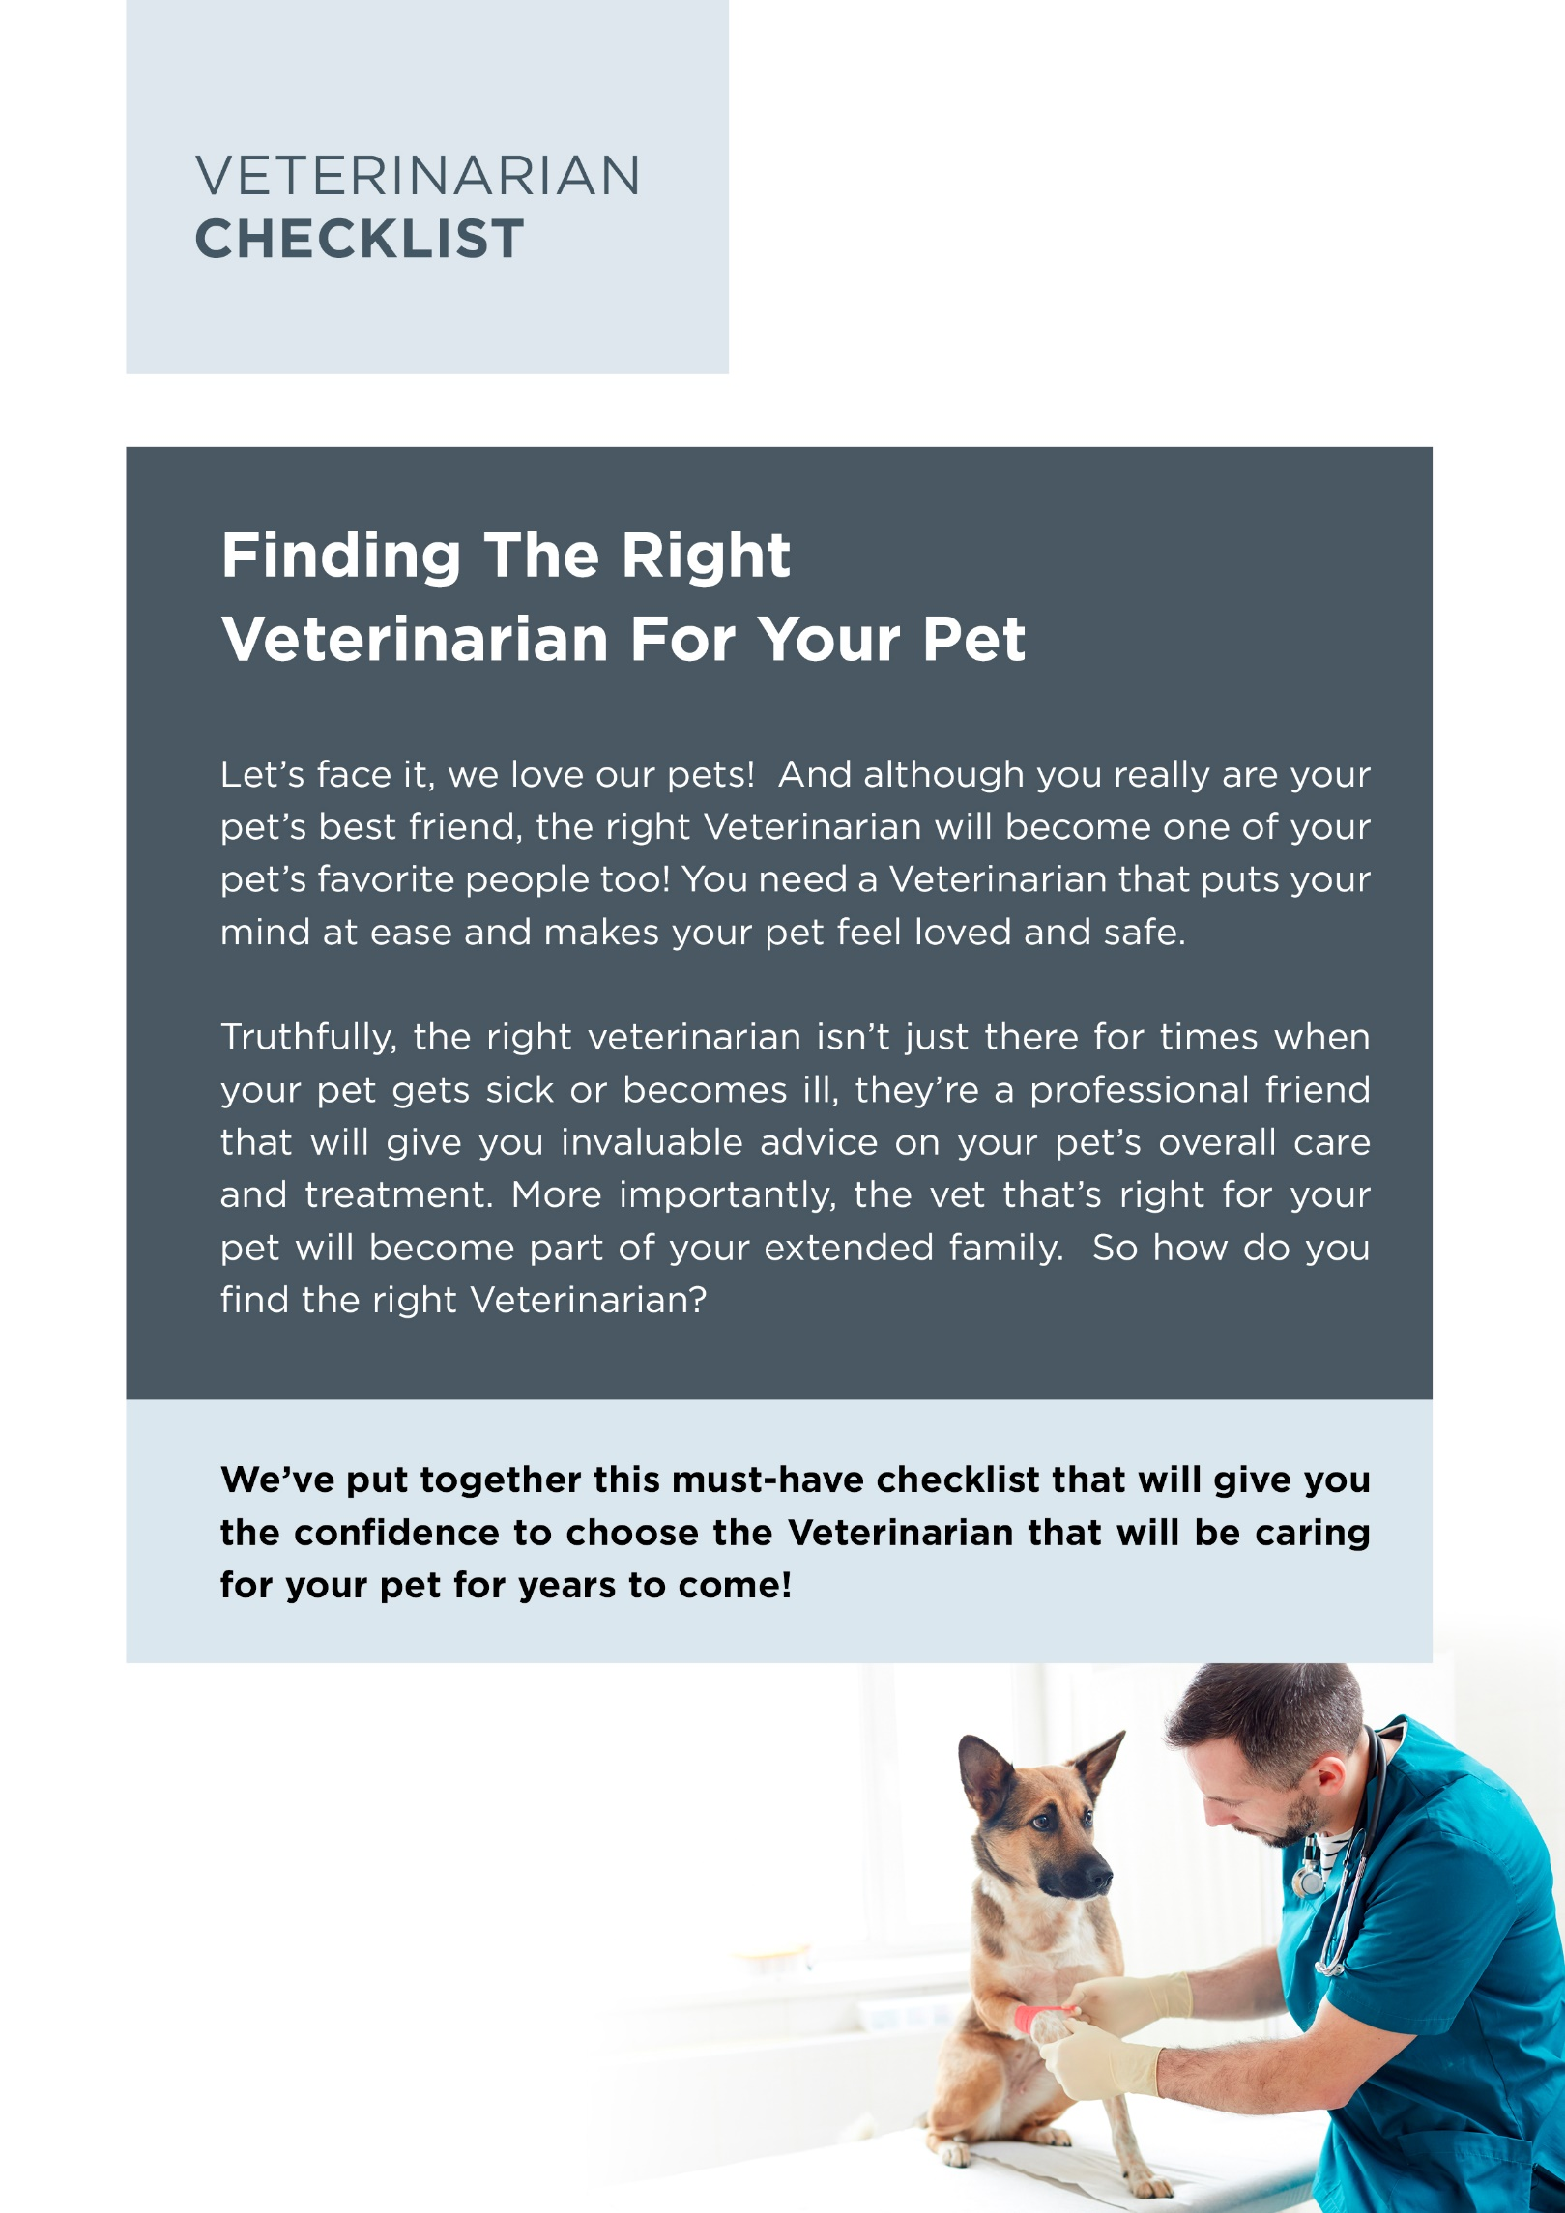
Brought To You By:

[Company Name]
[Company Phone]
[Company Website]

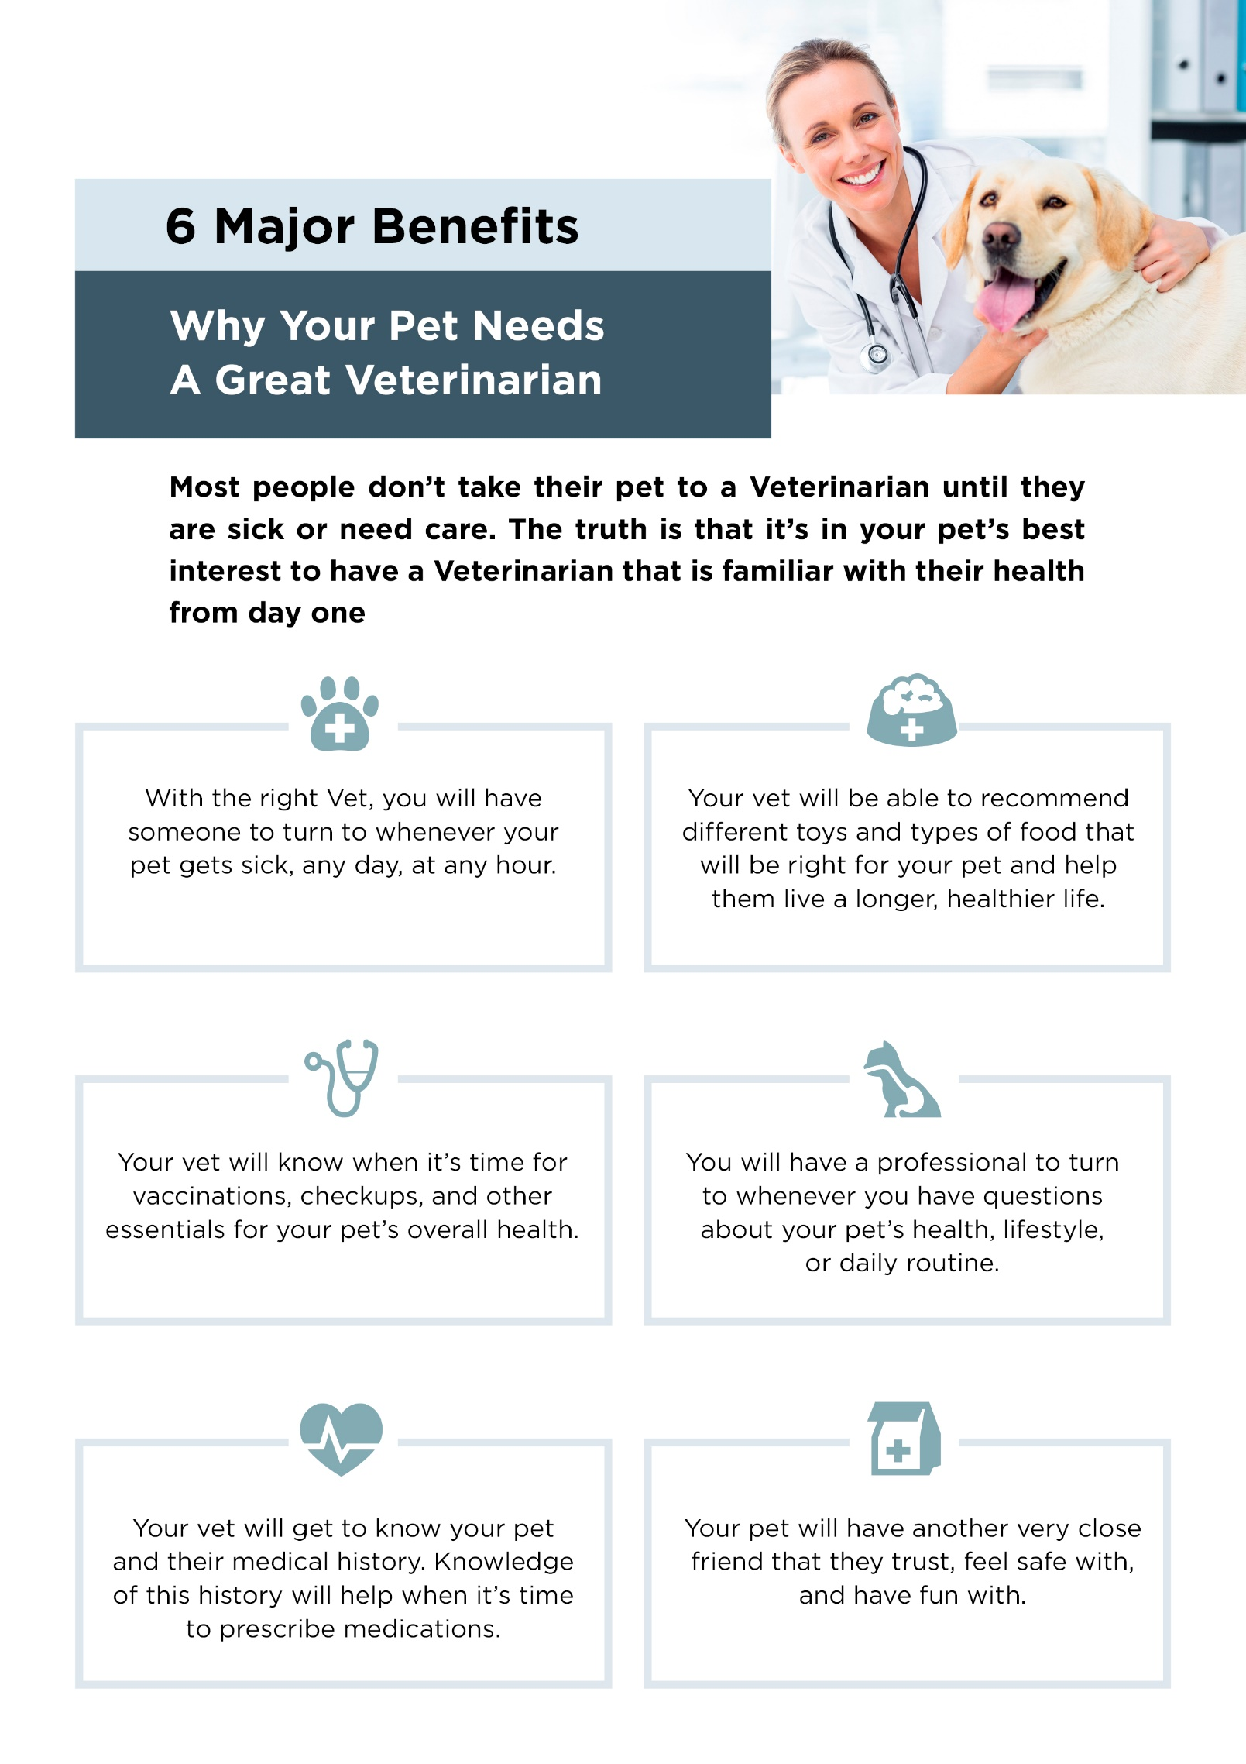

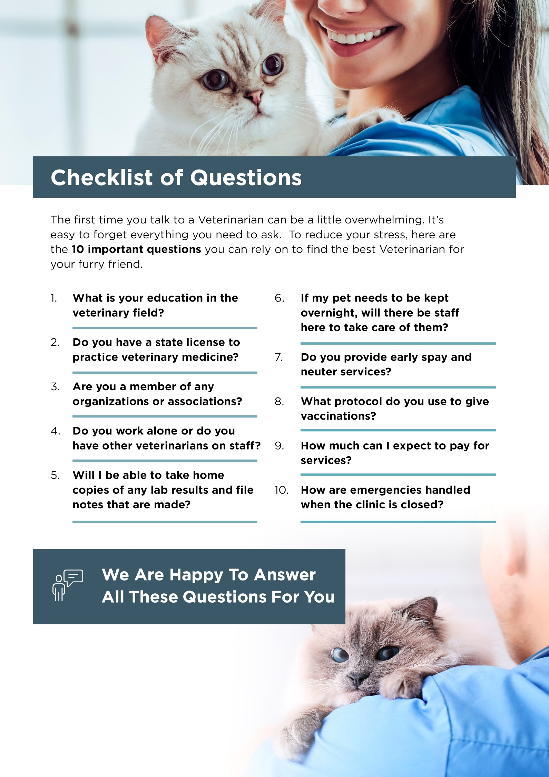
Contact Us Today:

[Company Name]
[Company Phone]
[Company Email]
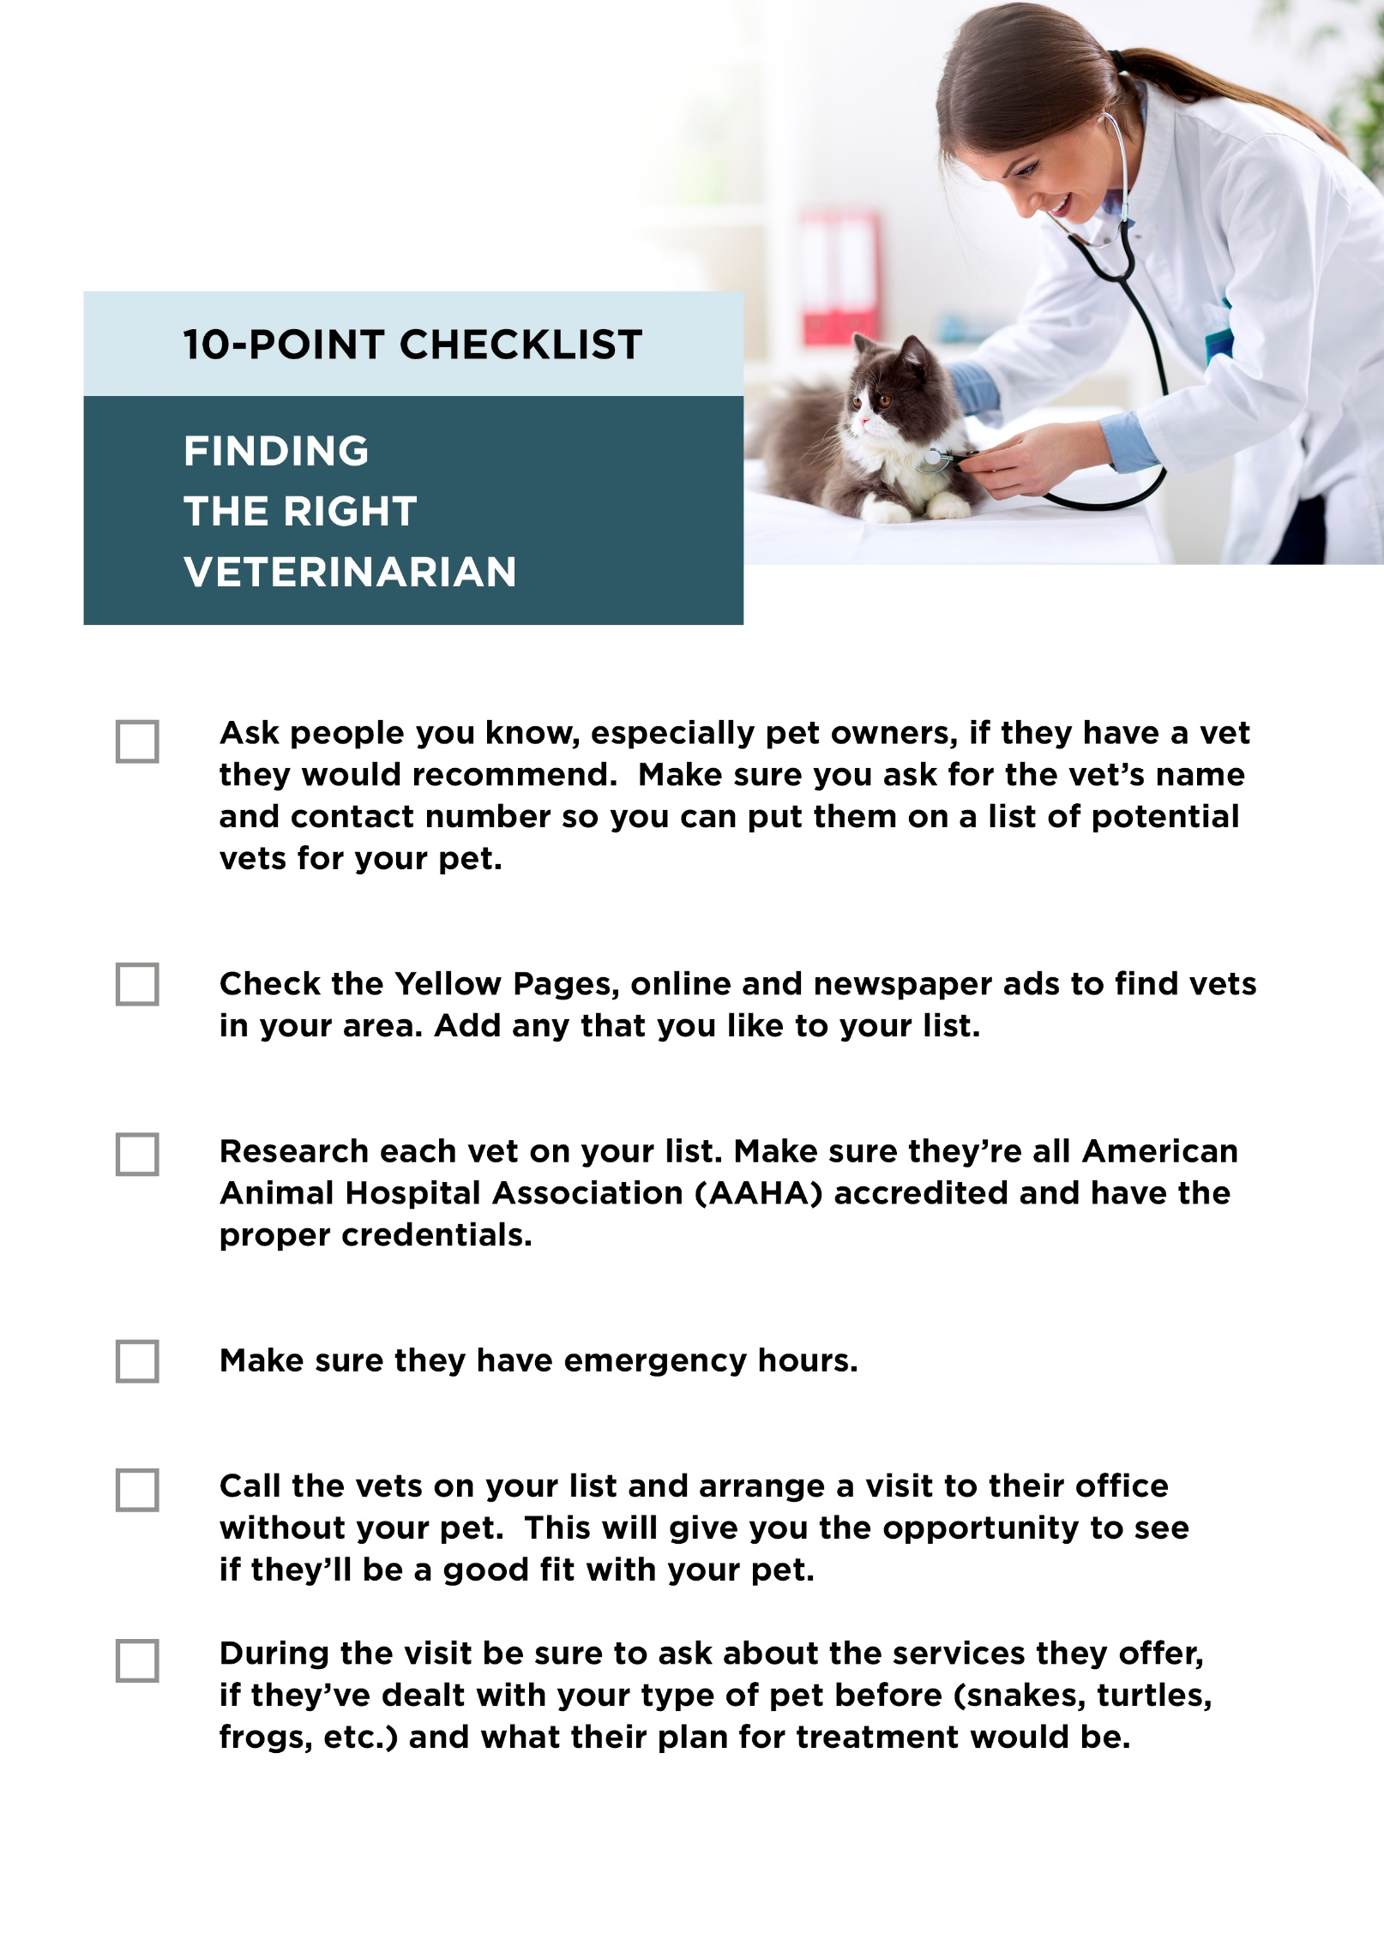

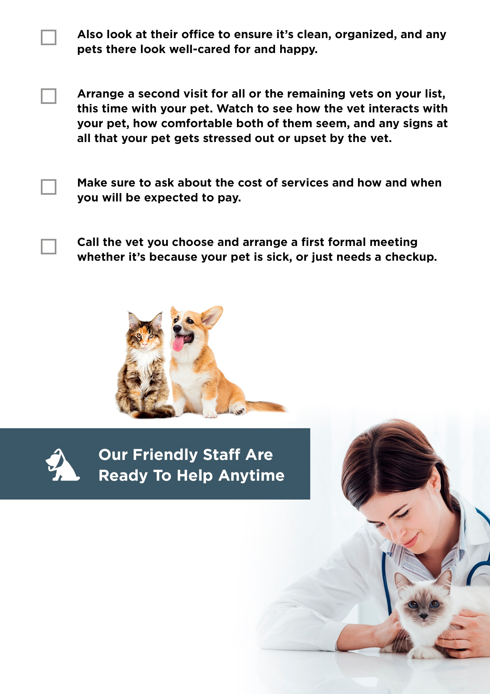
Contact Us Today:

[Company Name]
[Company Phone]
[Company Email]
[Company Website]

