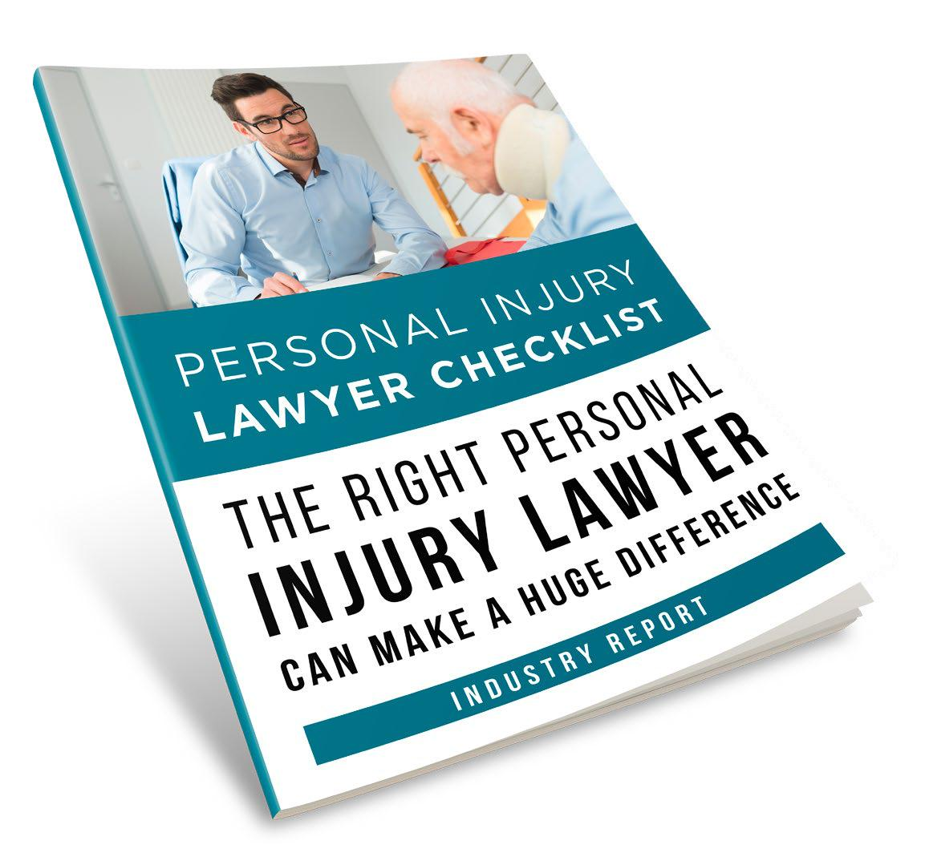

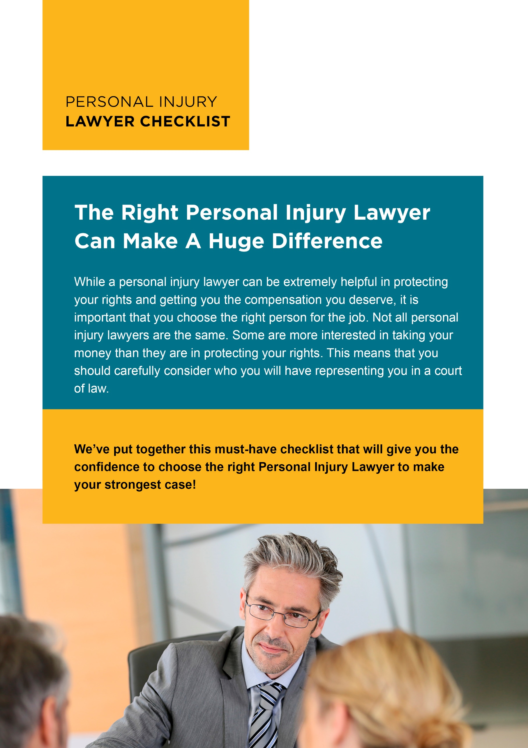

Brought To You By:

[Company Name]

[Company Phone]

[Company Website]



9 Major Benefits

Why You Should Consult

A Personal Injury Lawyer

In The Next 48 Hours!

Most people don’t talk to a Personal Injury Lawyer until it’s too late. When you’re worried, it’s easy to forget things and that could weaken your case. A great Personal Injury Lawyer will take the guesswork out of it all. Here are 9 invaluable benefits that will encourage you to talk to a great lawyer right away.

They will know how much your claim is worth

You’ll benefit from their knowledge of the legal process

Your chances of receiving fair compensation will increase

They’ll prepare you if the case does go to trial

They know how to help you deal with the insurance companies

You’ll receive a free consultation

They’ll help you understand the statute of limitations

They’ll advise you on the compensation you can expect

They will reduce your stress



Checklist of Questions

The first time you talk to a lawyer, it can be intimidating. It’s easy to forget everything you need to ask. To reduce your stress, here are the 8 important questions you can rely on to find the help you deserve.

What is your area of expertise?

Have you handled similar cases?

What were the outcomes?

What is your current caseload?


What are the strategies you’ll use to win my case?


Will you be the only lawyer working on my case?


How long do you think it will take for my case to be resolved?


What can I do to improve my chances of winning the case?


How will you keep me informed of my case’s progress?

How often do you go to trial?


How often do you win?


Our Friendly Staff

Are Ready To Help Anytime!

Contact Us Today:

[Company Name]

[Company Phone]

[Company Email]



10-POINT CHECKLIST

FINDING YOUR PERSONAL INJURY LAWYER

So now you’re ready! Just print off this guide and follow it step by step to help you weed out the best from the rest! We know this process can be intimidating and frustrating for you. So, we’ve taken the stress away with this quick 10-point checklist to make your search super easy.

Get referrals from trusted sources, like friends, family members or an organization such as the American Association for Justice (AAJ), the Better Business Bureau etc.

Check out consumer review websites like Angie’s List

Narrow your research to only include lawyers that are specialized in personal injury cases.


Don’t choose a lawyer based on their commercial.

You need more than just a flashy TV spot.

Call each of the choices you find, and ask if they provide free initial consultations. If they don’t, cross them off your list.

Set up a free consultation with each personal injury lawyer left on your list.

During the interview, ask all the questions you want and take careful notes.

Go home and compare all of your notes, narrowing down your choices.

Choose a personal injury lawyer to represent you.

Call the lawyer you’ve chosen and arrange a meeting to start discussing your case in more detail


Our Friendly Staff

Are Ready To Help Anytime!

Contact Us Today:

[Company Name]

[Company Phone]

[Company Website]

[Company Email]

