

Brought To You By:
[Company Name]
[Company Phone]
[Company Website]



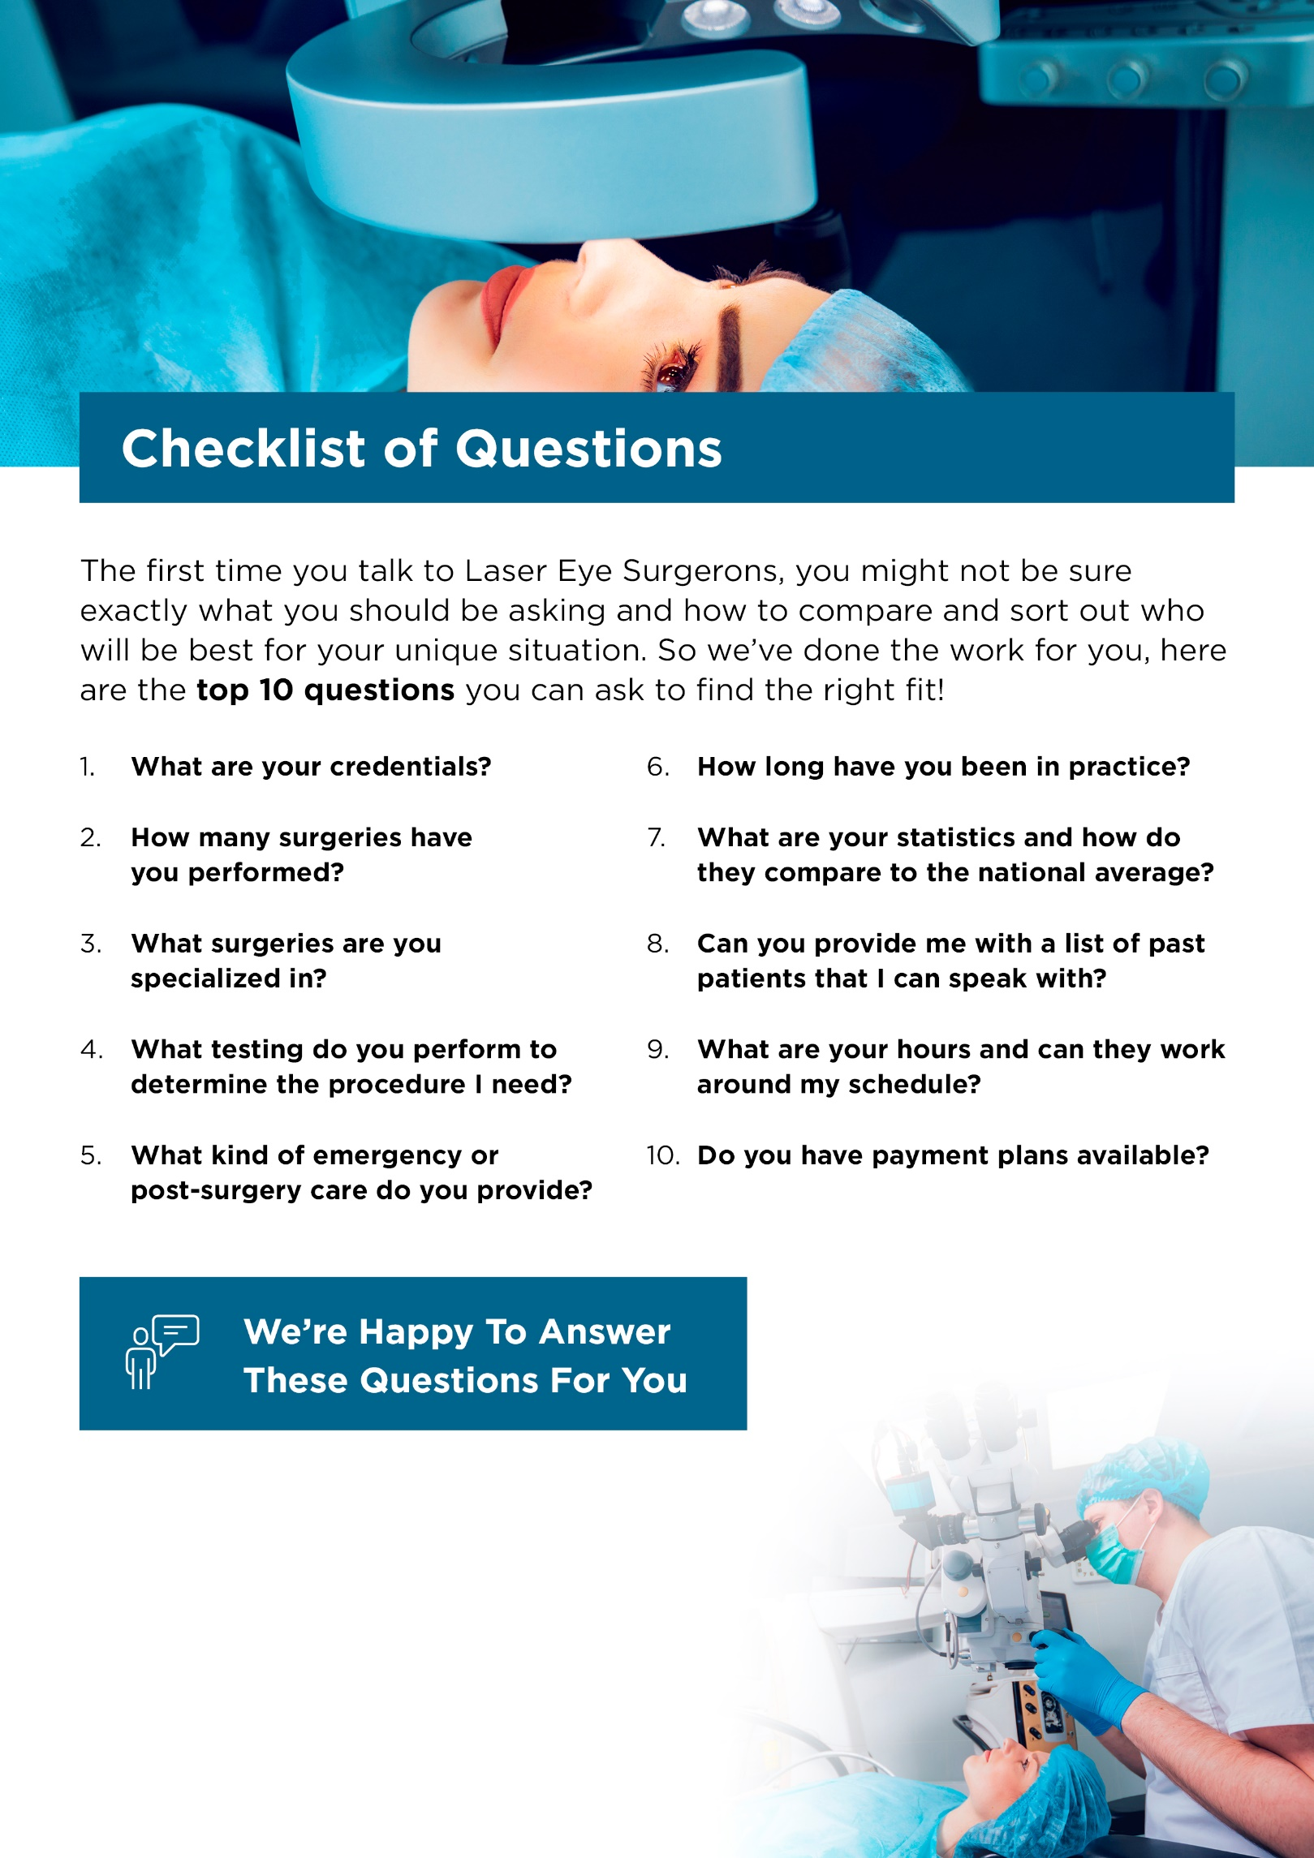
Contact Us Today:

[Company Name]
[Company Phone]
[Company Email]
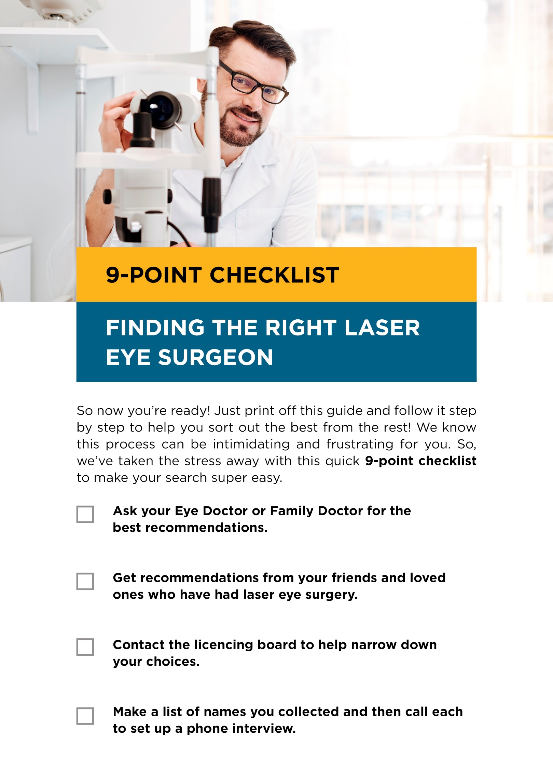

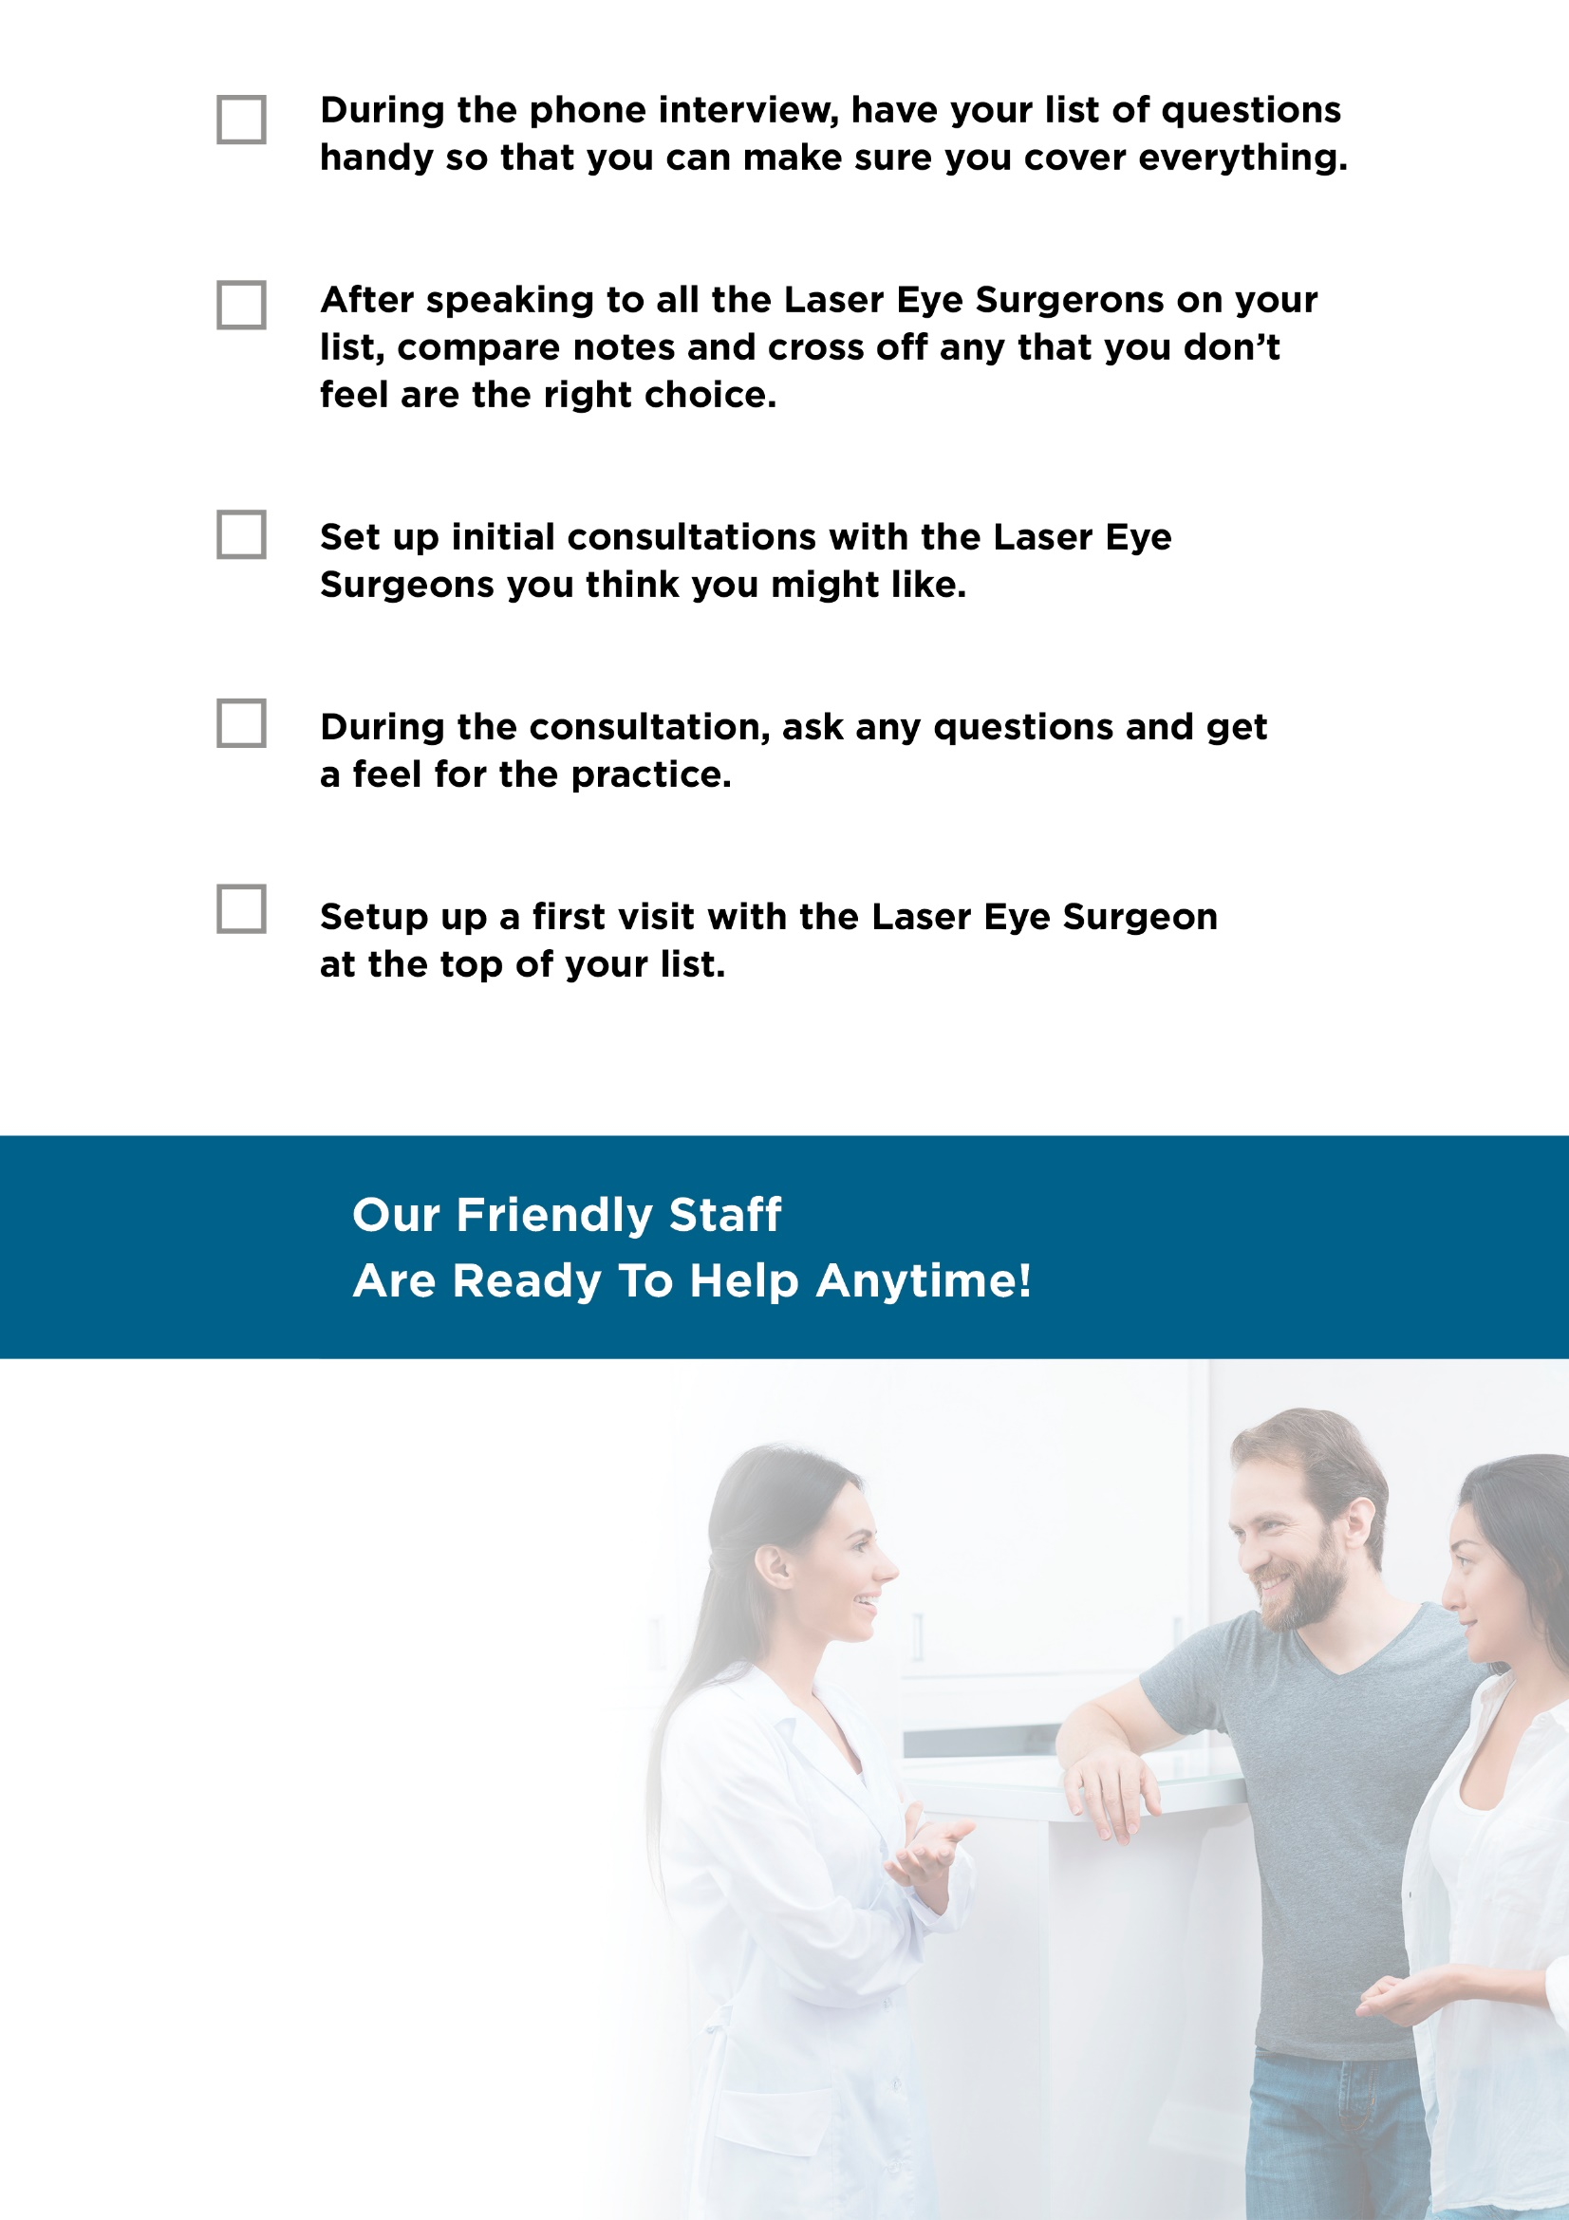
Contact Us Today:

[Company Name]
[Company Phone]
[Company Website]
[Company Email]

