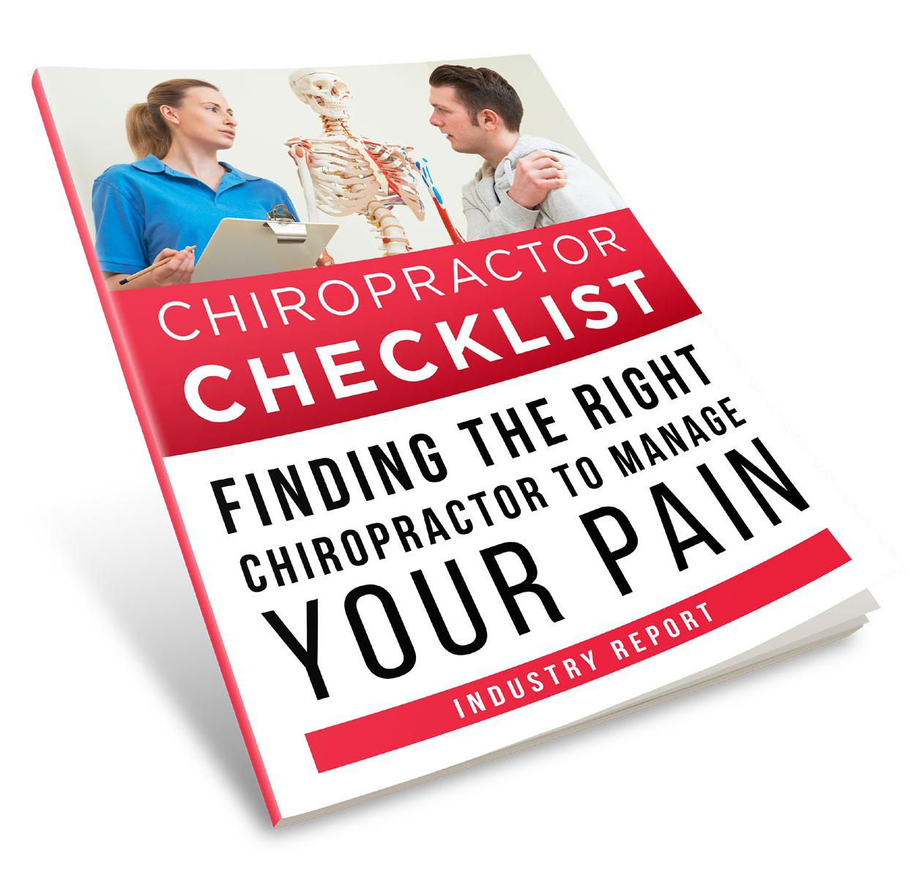

CHIROPRACTOR CHECKLIST

Brought To You By:

[Company Name]

[Company Phone]

[Company Website]

Finding The Right Chiropractor To Minimize Your Pain

Are you experiencing terrible back pain that’s keeping you from doing the things you love? If so, then you’ve probably been asked, “Why don’t you see a Chiropractor?” Or maybe you’ve been thinking about it for a while.

A Chiropractor is usually the first person we think of when we hear of back pain. Let’s face it, that’s because Chiropractors are pretty known for treating this type of pain every single day. But, like any industry, there’s a lot of myths that keep us away; safety issues, concerns over the effectiveness of treatment, high costs... just a few of the reasons many of us are still hesitant to book a consultation. But getting over that fear is pretty important if you’re hoping to feel better anytime soon.

Now, we’ve got something really special that we’ve compiled for you, to eliminate your stress and get you on your way to the right Chiropractor very soon!



The Benefits Of Working

With A Great Chiropractor

Do you know that your first visit with a Chiropractor can ease your pain?

What if the right Chiropractor can help you feel better every single day?

Here are our top 4 benefits of working with the right Chiropractor!

Did you know that Chiropractors can often figure out what’s causing your pain? They frequently eliminate the need for surgery, often with minimal to no medication. Before you decide to undergo surgery, a visit to the right Chiropractor might make a big impact on that decision.


Most patients experience relief as early as the first treatment and issues are often resolved within 4 to 6 visits. Generally speaking, patients do return for follow-ups, to prevent future issues.


Visiting a Chiropractor can be especially helpful if you’ve already had surgery. Don’t worry, your Chiropractor will take x-rays and become familiar with your case before any treatment is suggested. The good news is that regular adjustments can often help you prevent a second surgery.


Where your doctor prescribes medication, (known to help patients with similar symptoms), a Chiropractor uses alternative techniques. Analyzing your situation based on a series of tests and working with your individual needs. With a Chiropractor, you receive customized treatments based on your unique circumstances.



Checklist Of Questions

The first time you talk to Chiropractors, you might not be sure exactly what you should be asking and how to compare and sort out who will be best for your unique situation. So we’ve done the work for you, here are the top 10 questions you can ask to get you to the best!

- What educational background do you have?

- Do you offer a free consultation?

- What tools and equipment do you use in your practice?

- Do you take x-rays?

- What techniques do you use?

- How will treatment work and how will you measure progress?

- What kind of preventative care do you recommend?

- Will you put your recommendations in writing?

- How much will it cost?

- Do you have payment plans available?


We’re Happy

To Answer

These Questions

For You

Contact Us Today

[Company Name]

[Company Phone]

[Company Email]



9-POINT CHECKLIST

FINDING THE BEST CHIROPRACTOR

So now you’re ready! Just print off this guide and follow it step by step to help you weed out the best from the rest! We know this process can be intimidating and frustrating for you. So, we’ve taken the stress away with this quick 9-point checklist to make your search super easy.

Speak with your doctor to ask if they think a Chiropractor would help.

Get names of Chiropractors from your friends who have seen Chiropractors for treatment.

Make a list of names you collected and then call each to set up a phone interview.

During the phone interview, have your list of questions handy so that you can make sure you cover everything.

After speaking to all the Chiropractors on your list, compare notes and cross off any that you don’t feel are the right choice.

Set up initial consultations with the Chiropractors you think you might like.

During the consultation, ask any questions and get a feel for the office.

Setup up a first visit with the Chiropractor at the top of your list.

Have a timeline set in place so you can determine when treatment should start working and what to do if you’re not hitting those markers.


Our Friendly Staff

Are Here To Help Anytime

Contact Us Today:

[Company Name] [Company Phone] [Company Website] [Company Email]

