


[Company Name]
[Company Phone]
[Company Website]
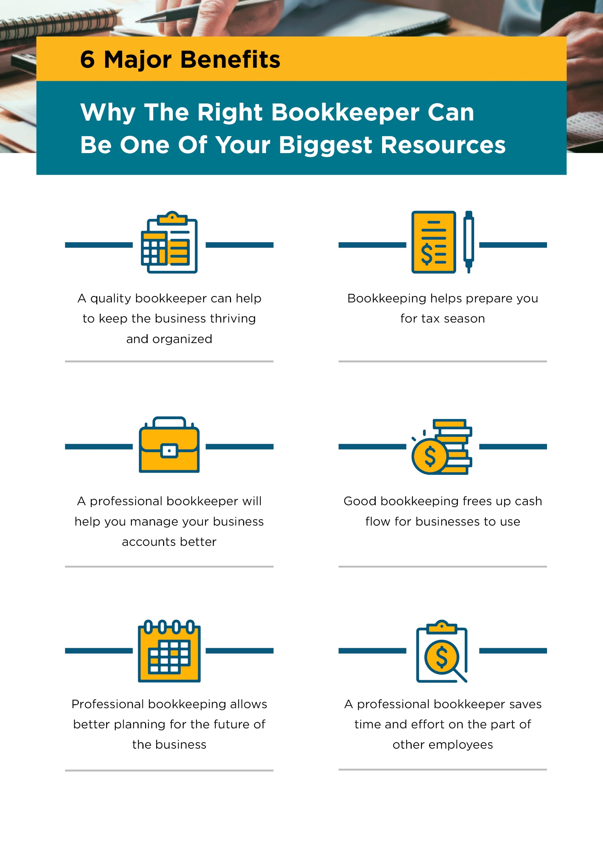

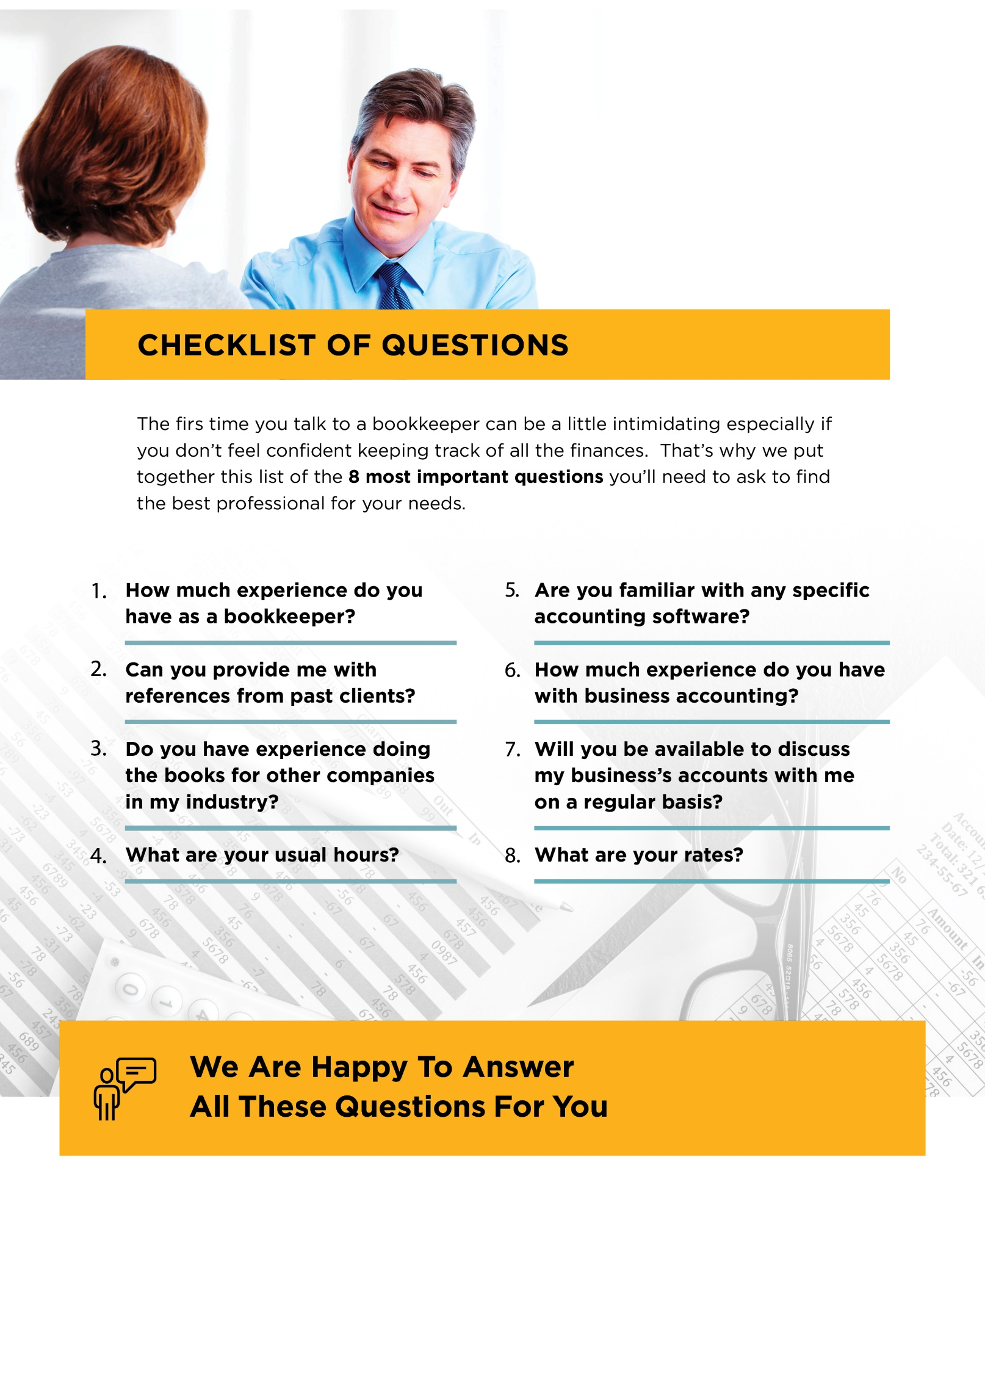
Contact Us Today:

[Company Name]
[Company Phone]
[Company Website]



Contact Us Today:

[Company Name]
[Company Phone]
[Company Website]
[Company Email]

